**Multiple Currency**

**Web (Enhancement)**

**Contents:**

Business Requirement: .....................................................................................................................3 Multiple Currency Current Flow (Web)………………………………………………............................................4

Multiple Currency Proposed Flow (Web)……………………………………………….........................................9

Impact:……………………………………………………………………………………………………………………….................13

# Business Requirement

The Multiple Currency Rule Business requirements are:

1. In the Current flow only the currency of the Country in which subscription was made is visible in the Dashboard in the boxes- Incomplete Expenses, Pending with Approver, Pending Finance Approval, Pending Passed for Payment, Passed for Payment. Under, Go To Credit Card - Year to Date, currency of the Country in which subscription was made is visible. Under Liability Report, in the grid columns- Current Month (Amount GBP), Previous Month (Amount GBP), Other Month (Amount GBP) and Total Month (Amount GBP), currency of the Country in which subscription was made is visible. In Incomplete page from Liability Report by clicking on any record, in the grid columns- Current Month (Amount GBP), Previous Month (Amount GBP), Other Month (Amount GBP) and Total Month (Amount GBP)
2. The currency of other countries is not visible in any of the areas listed in point a, hence the UX becomes confusing.
3. The Amount option should be removed from all the boxes- Incomplete Expenses, Pending with Approver, Pending Finance Approval, Pending Passed for Payment, Passed for Payment. So that user should not get confused
4. The currency should be removed from the areas- Go To Credit Card Dashboard- Year to Date, currency of the Country in which subscription was made is visible. Under Liability Report, in the grid columns- Current Month (Amount GBP), Previous Month (Amount GBP), Other Month (Amount GBP) and Total Month (Amount GBP)
5. Navigate to Incomplete page from Liability Report by clicking on any record with Incomplete Expense Status, in the grid columns- Current Month (Amount GBP), Previous Month (Amount GBP), Other Month (Amount GBP) and Total Month (Amount GBP)
6. Navigate to Incomplete page from Liability Report by clicking on any record with Rejected Expense Status, in the grid columns- Current Month (Amount GBP), Previous Month (Amount GBP), Other Month (Amount GBP) and Total Month (Amount GBP)
7. Navigate to Incomplete page from Liability Report by clicking on any record with Pending With Approver Expense Status, in the grid columns- Current Month (Amount GBP), Previous Month (Amount GBP), Other Month (Amount GBP) and Total Month (Amount GBP)
8. Navigate to Incomplete page from Liability Report by clicking on any record with Approved Expense Status, in the grid columns- Current Month (Amount GBP), Previous Month (Amount GBP), Other Month (Amount GBP) and Total Month (Amount GBP)
9. Navigate to Incomplete page from Liability Report by clicking on any record with Approved For Payment Expense Status, in the grid columns- Current Month (Amount GBP), Previous Month (Amount GBP), Other Month (Amount GBP) and Total Month (Amount GBP)
10. This document will cover the current flow and the proposed flow.
11. This enhancement does not have any impact on mobile or any other functions on web.

# Multiple Currency: Current flow - Web

1. On the Dashboard (**Screen 1**), currently user can see only the currency of the Country in which subscription was made.

**Screen 1**

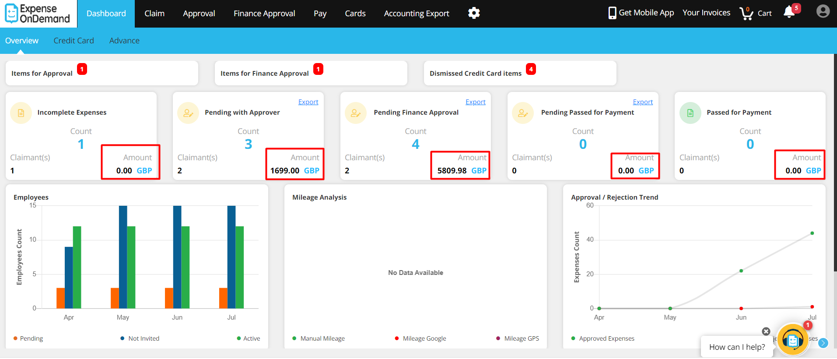

1. Under, Go To Credit Card - Year to Date (**Screen 2**),currently user can see only the currency of the Country in which subscription was made.

**Screen 2**

1. Under Liability Report, in the grid columns- Current Month (Amount GBP), Previous Month (Amount GBP), Other Month (Amount GBP) and Total Month (Amount GBP) ( **Screen 3** ),currently user can see only the currency of the Country in which subscription was made.

**Screen 3**

1. From **Liability Report** page, when navigated to **Incomplete** Expense Status page, then in the grid columns- Current Month (Amount GBP), Previous Month (Amount GBP), Other Month (Amount GBP) and Total Month (Amount GBP) ( **Screen 4** ),currently user can see only the currency of the Country in which subscription was made.

**Screen 4**

1. From **Liability Report** page, when navigated to **Rejected** Expense Status page, then, in the grid columns- Current Month (Amount GBP), Previous Month (Amount GBP), Other Month (Amount GBP) and Total Month (Amount GBP) ( **Screen 5** ),currently user can see only the currency of the Country in which subscription was made.

**Screen 5**

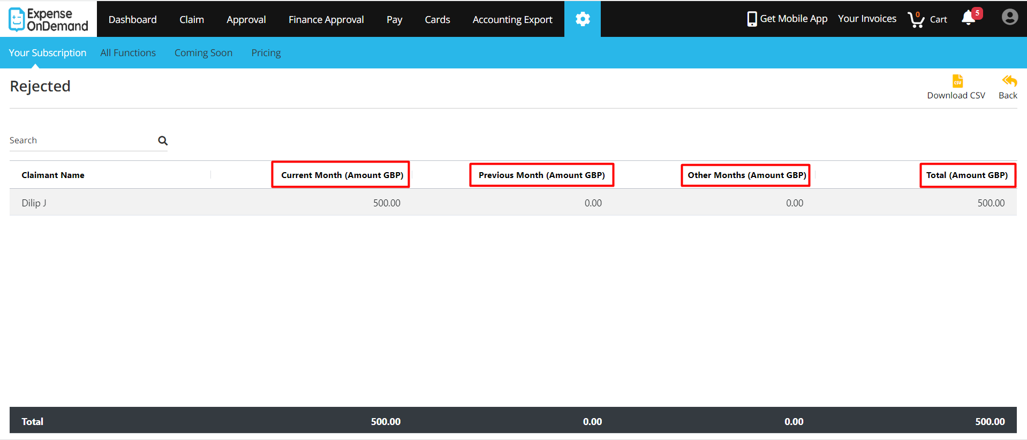

1. From **Liability Report** page, when navigated to **Pending With Approver** Expense Status page, then, in the grid columns- Current Month (Amount GBP), Previous Month (Amount GBP), Other Month (Amount GBP) and Total Month (Amount GBP) ( **Screen 6** ),currently user can see only the currency of the Country in which subscription was made.

**Screen 6**

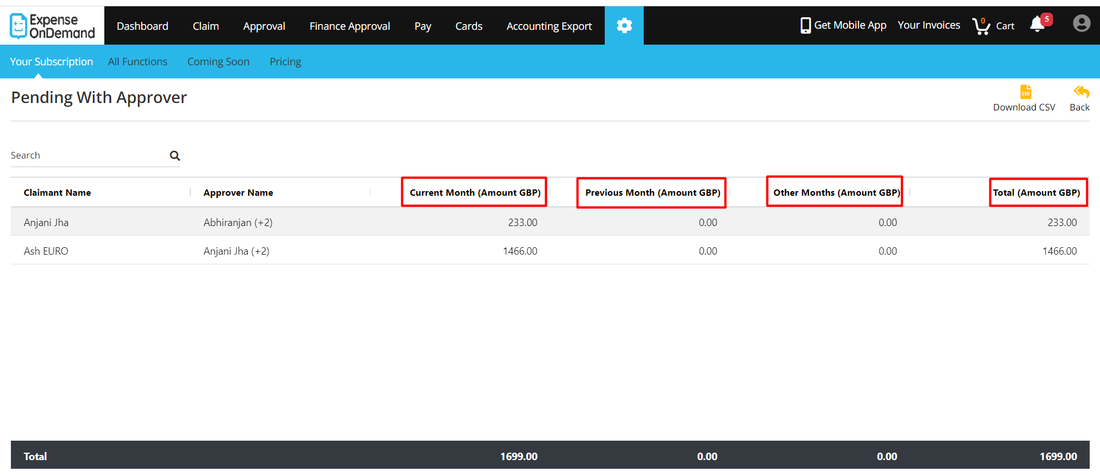

1. From **Liability Report** page, when navigated to **Approved** Expense Status page, then, in the grid columns- Current Month (Amount GBP), Previous Month (Amount GBP), Other Month (Amount GBP) and Total Month (Amount GBP) ( **Screen 7** ),currently user can see only the currency of the Country in which subscription was made.

**Screen 7**

1. From **Liability Report** page, when navigated to **Approved For Payment** Expense Status page, then, in the grid columns-- Current Month (Amount GBP), Previous Month (Amount GBP), Other Month (Amount GBP) and Total Month (Amount GBP) ( **Screen 8** ),currently user can see only the currency of the Country in which subscription was made.

**Screen 8**

1. **Problem Statement**:
   1. In the Current flow, from dashboard, Go To Credit Card, Liability Report and Liability Report- Expense status as Incomplete, Rejected, Pending With Approver, Approved, Approved For payment, user is unable to see the other counties currency. Only the currency of the Country in which subscription was made.
   2. The UX becomes confusing.

# Multiple Currency: Proposed flow - Web

1. From the **Dashboard**, the new screen ( **Screen 9**), will not show the **Amount** option in the following boxes:
   1. **Incomplete Expenses**
   2. **Pending with Approver**
   3. **Pending Finance Approval**
   4. **Pending Passed for Payment**
   5. **Passed for Payment**

**Screen 9**

1. From **Go To Credit Card** link present at the bottom of the Dashboard, the new screen (**Screen 10**),will not show the **Currency** in the **Year to Date** box.

**Screen 10**

1. From **Liability Report** link present at the bottom of the Dashboard, the new screen (**Screen 11**), will not show the **Currency** present under the grid.

**Screen 12**

1. From **Liability Report** page, when navigated to **Incomplete** Expense Status page, the new screen (**Screen 13**),will not show the **Currency** present under the grid.

**Screen 13**

1. From **Liability Report** page, when navigated to **Rejected** Expense Status page, the new screen (**Screen 14**),will not show the **Currency** present under the grid.

**Screen 14**

1. From **Liability Report** page, when navigated to **Pending With Approver** Expense Status page, the new screen (**Screen 15**),will not show the **Currency** present under the grid.

**Screen 15**

1. From **Liability Report** page, when navigated to **Approved** Expense Status page, the new screen (**Screen 16**),will not show the **Currency** present under the grid.

**Screen 16**

1. From **Liability Report** page, when navigated to **Approved For Payment** Expense Status page, the new screen (**Screen 17**),will not show the **Currency** present under the grid.

**Screen 17**

**4 Impact(s):**

1. There is no impact for this enhancement on other functions.